**TIME**

**Matplotlip**

**Top Country Spenders by the hour – Legend added**

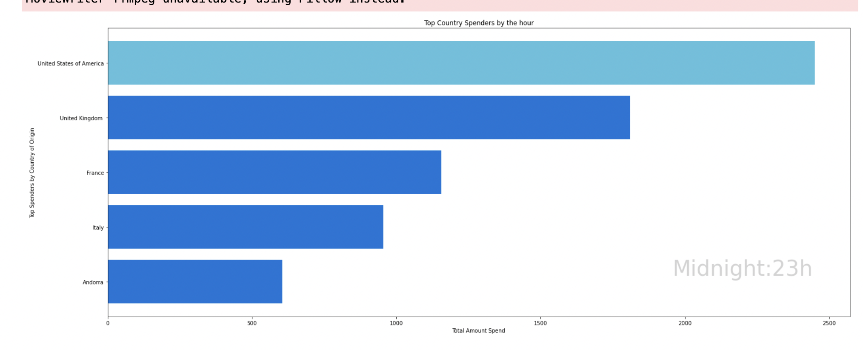

Category-Country Spenders by the hour – Color by category and add legend

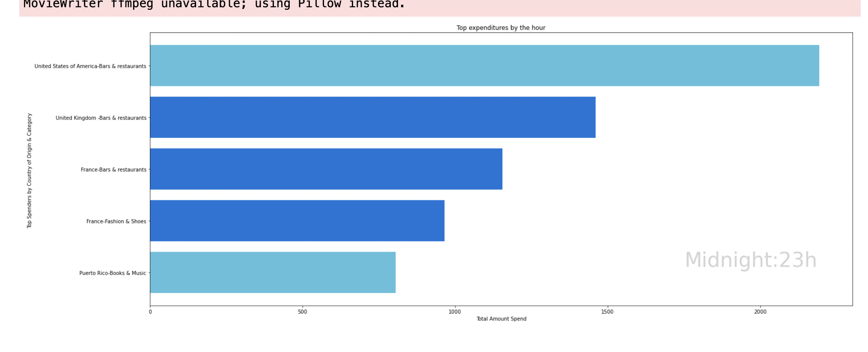

GGPlot – White background and layout

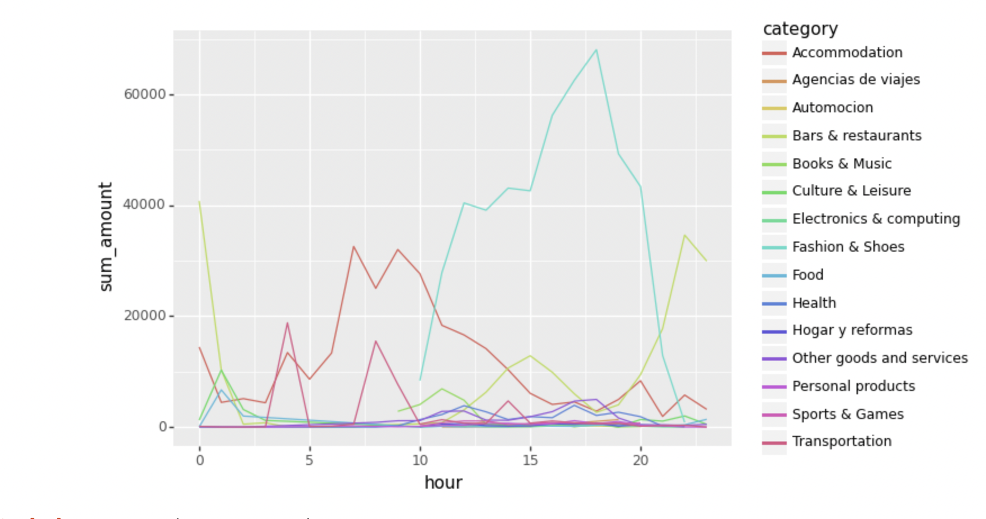

GGPLOT – Friday/ Thursday to be better visible, clustering of time, white background, Title

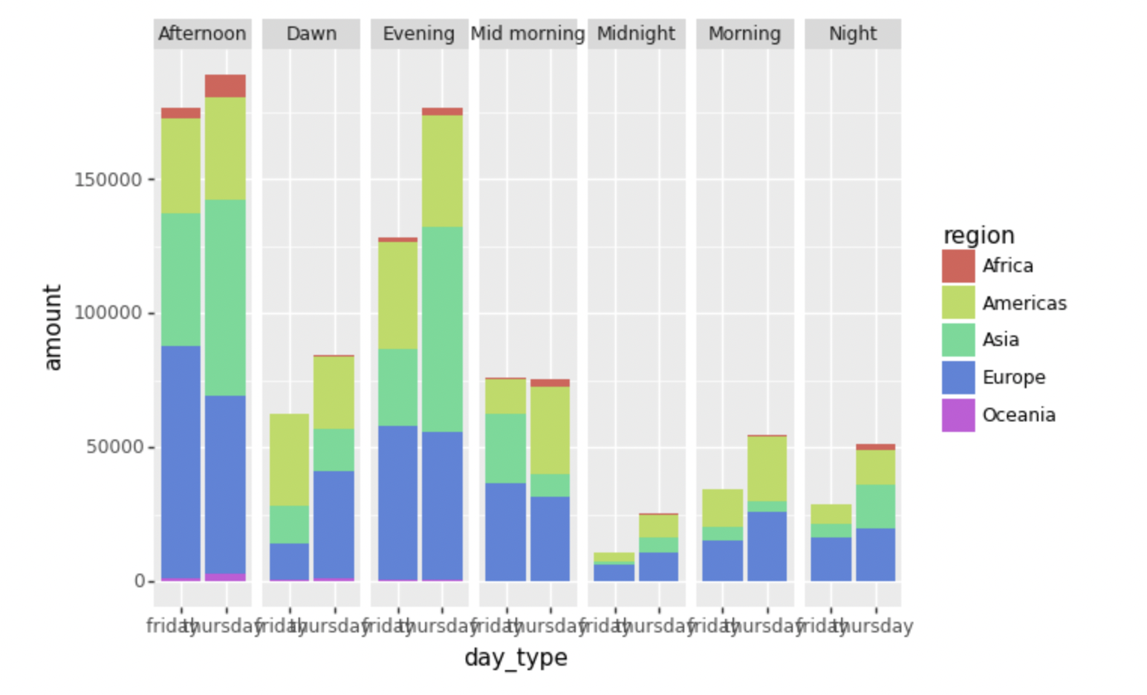

High level – white background, check if the metric is total amount, check where the money spend, (maybe remove outliers)

GGplot -Total amount

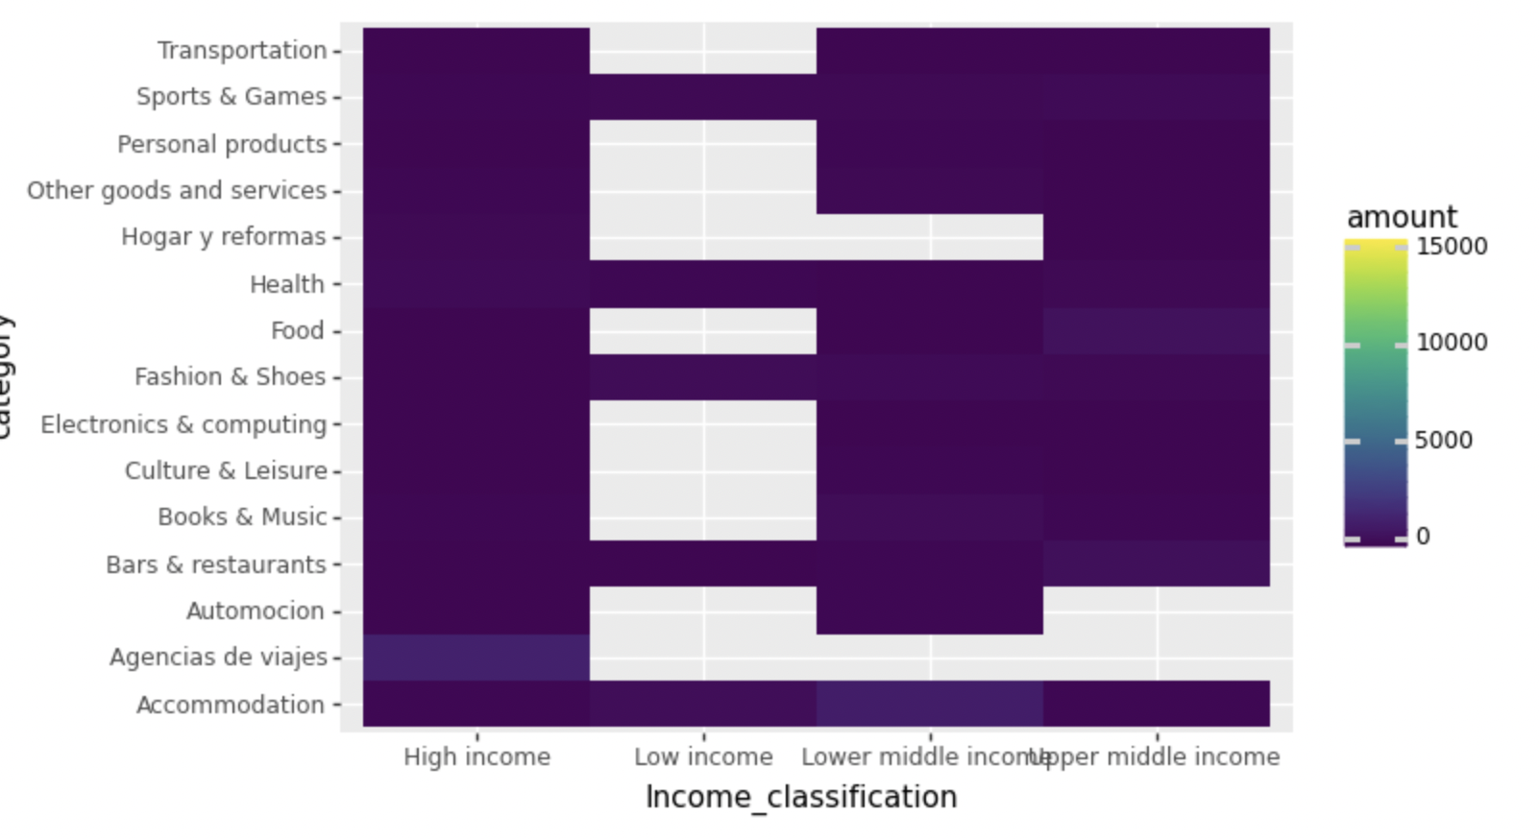

PLOTLY

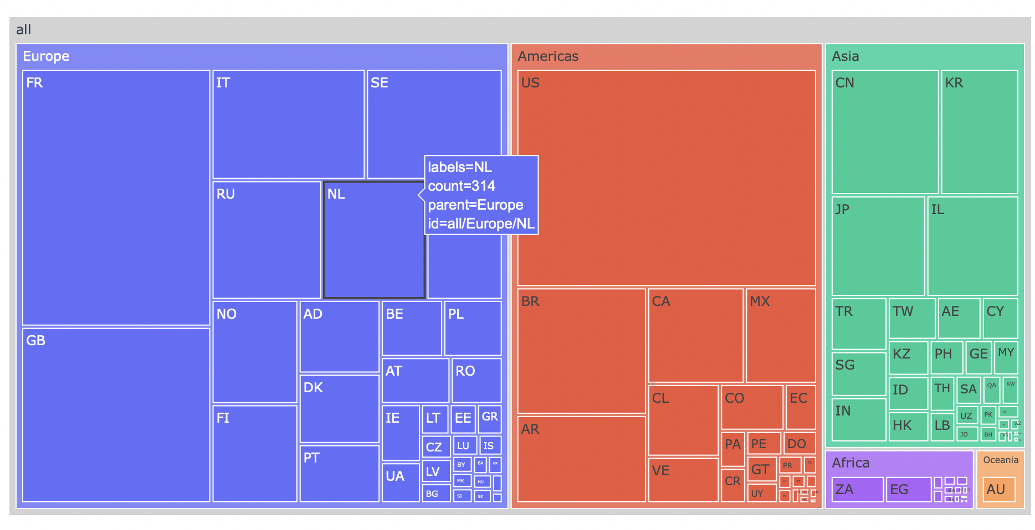

GGPLOT – dataset from Jorge’s – Removing outliers, and colorful, labels 45 degrees, title

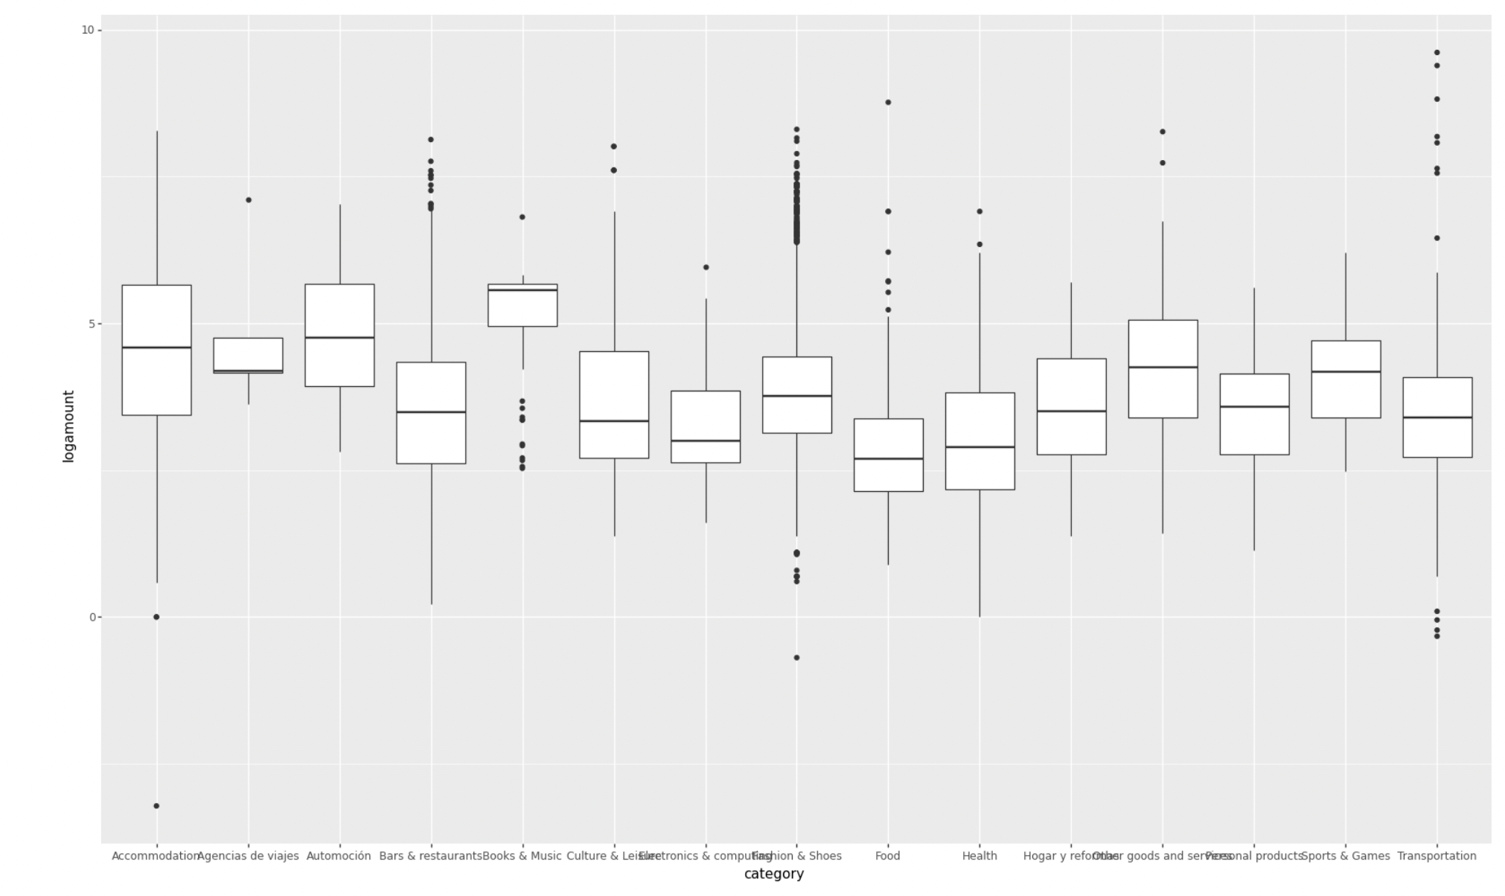

Plotly: Juan

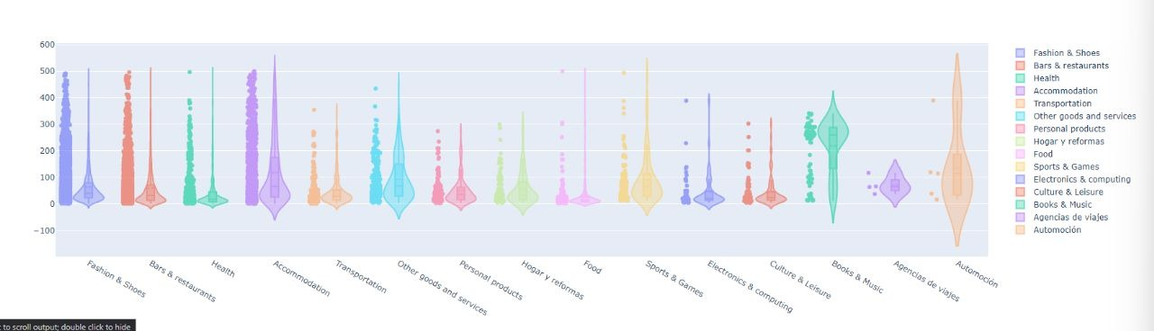

Actual and future outlook

Spider: plotly

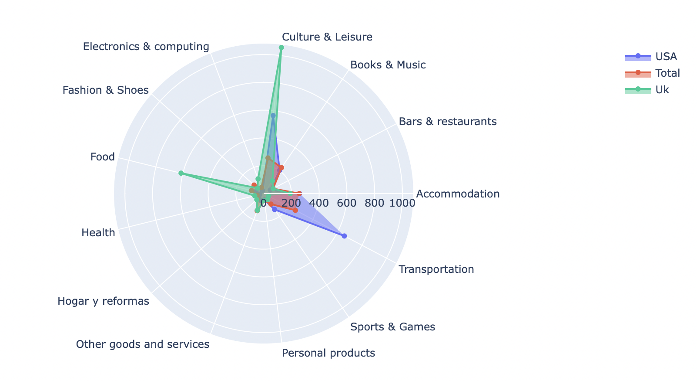

Boston Consulting matrix by country : plotly

Keep: add “real”

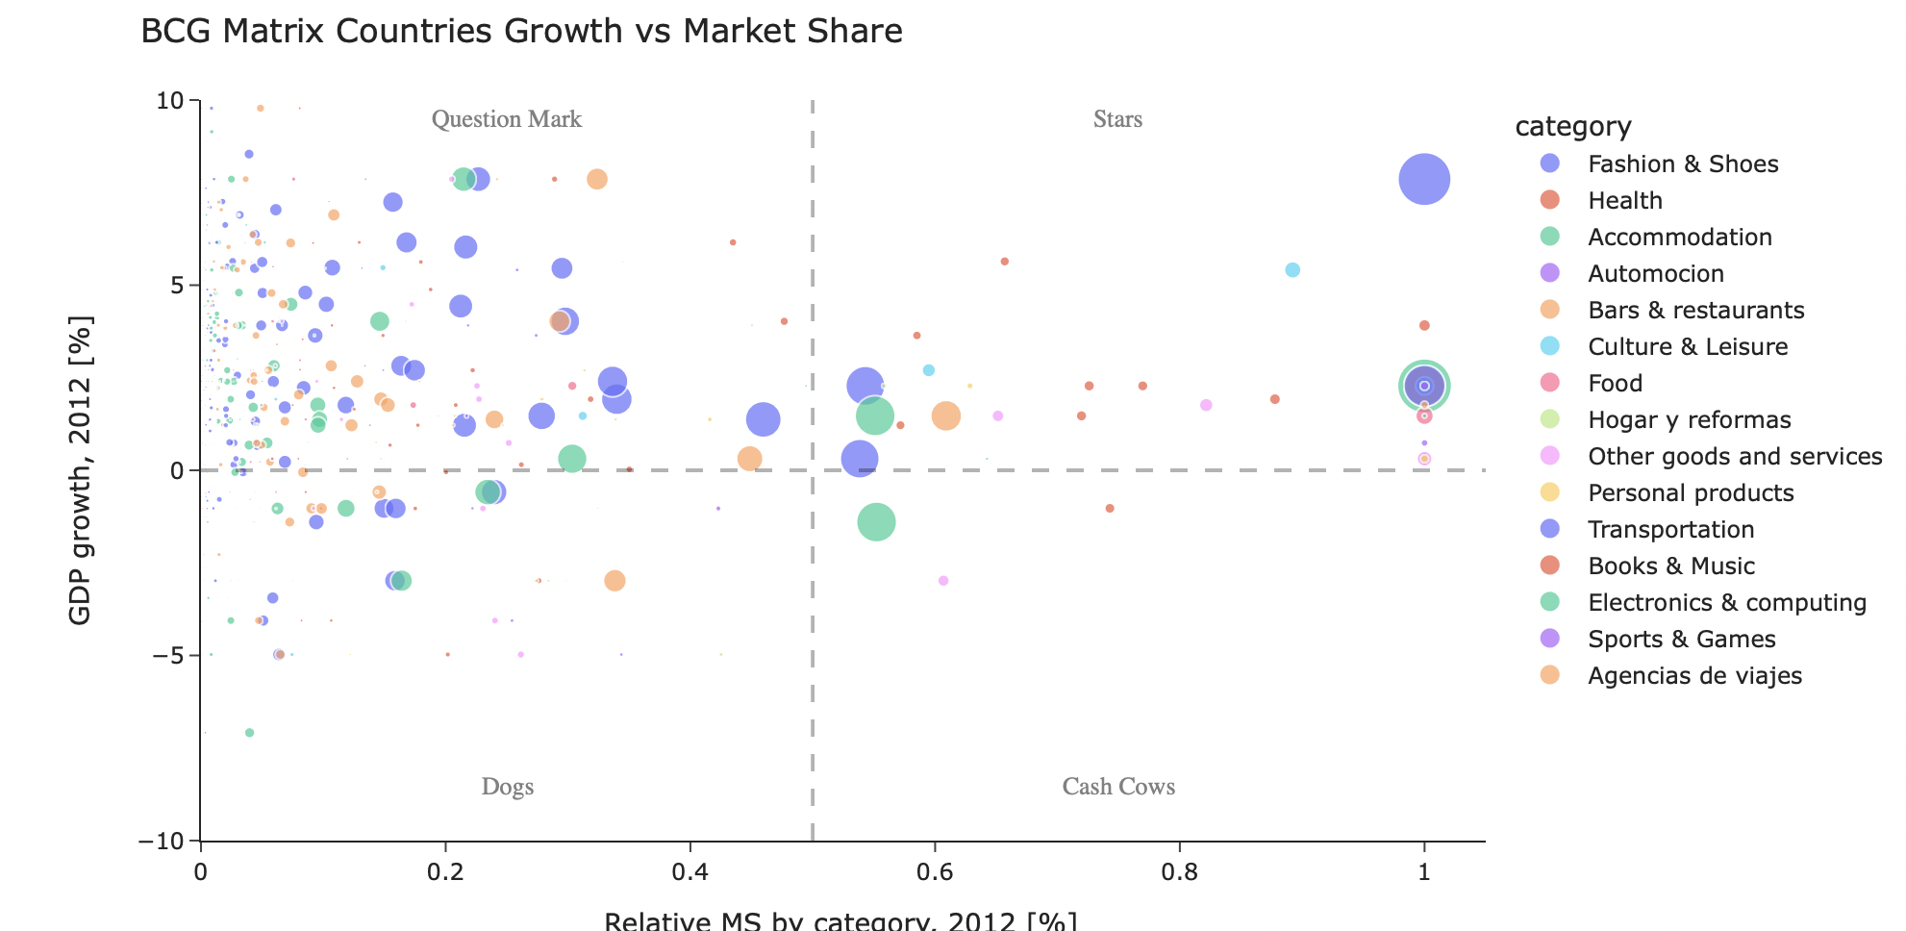

GGPLOT – add footnote for the blue line, remove labels, footnote countries are ranked on total amount

